

**Jagannath University**

**Dept.of Computer Science And Engineering**

**Course Title :** Computer Peripherals and Interfacing Lab

**Course Code** : CSEL-3208

# **Project Proposal On** “Solar Tracker System”

Submitted To,

Tanvir Ahammad Submitted By,

Lecturer Aminul Islam Rafi

Department of CSE **Id**: B180305022

Jagannath University Md.Raihan Karim Priyo

**Id:** B180305034

Date of Submission : 21– 08 - 2022

**Table of Contents**

|  |  |  |
| --- | --- | --- |
| S.L. No. | Contents | Page No. |
| 1 | Problem Statement | 03 |
| 2 | Objectives | 04 |
| 3 | Features | 04 |
| 4 | Workflow Diagram | 05 |
| 5 | Tools and Device | 06 |
| 6 | References | 06 |

**Problem Statement**

# Generally, Solar Panels are stationary and do not follow the movement of the sun. Because of this disadvantage of solar panel – it can only work efficiently only if the presence of the sun is strong and we all know that the incident of the sunlight changes or moves with the time of the day. Solar tracker system is used to tracks the sun’s movement across the sky and tries to maintain the solar panel perpendicular to the sun’s rays, ensuring that the maximum amount of sunlight is incident on the panel throughout the day.

**Objectives**

This system works on the following aspect’s :

* To reduce the effort of the manpower and non computerized environment.
* To decreased cumbersome of the manpower to move the panel statically where the sun light is directly.
* To make a budget friendly system.
* To controlled the system by the tracking controller.
* To provides the simple structure.
* To provide the user a easy installation process.
* To provides the flexible response and good reliability.
* As survey show that compared with tradition fixed installation the generating capacity can be increased by 25% .

**Features**

* This system added the technology of the single axis tracking sun Light for solar panel.
* This system use the maximum energy of the sun power.
* Trackers generate more electricity than their stationary counterparts due to increased direct exposure to solar rays .This increase can be as much as 10 to 25% depending on the geographic location of the tracing system.
* Solar tracker generate more electricity in roughly the same amount of space needed for fixed –tilt systems, making then ideal for optimizing land usage.
* Advancements in technology and reliability in electronics and mechanics have drastically reduced long –term maintenance concerns for tracking systems.

**Workflow Diagram**

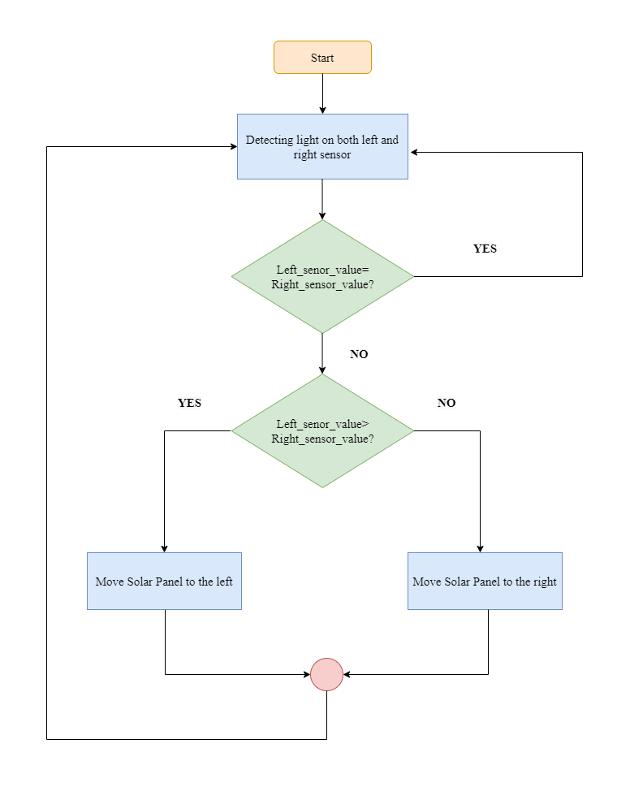

**Tools And Devices**

* 5mm Acrylic sheet
* VPC Card Board.
* Ardunio UNO.
* LDR Sensor (2).
* Mini Servo Motor.
* USB DC 1 ~5v to DC 5v Voltage Step Up Boost Module.
* On/Off Switch.
* 18650 Batter Holder -1 cell.
* 18650 Battery Cell 3.7v.
* LiPo Battery Charger Module Mini Tp4056 ic.

**References**

* Sefa, Ibrahim, Mehmet Demirtas, and Ilhami Çolak. "Application of one-axis sun tracking system." *Energy conversion and Management* 50.11 (2009): 2709-2718.
* Sefa, I., Demirtas, M., & Çolak, I. (2009). Application of one-axis sun tracking system. *Energy conversion and Management*, *50*(11), 2709-2718.
* Sefa, Ibrahim, Mehmet Demirtas, and Ilhami Çolak. "Application of one-axis sun tracking system." *Energy conversion and Management* 50, no. 11 (2009): 2709-2718.